



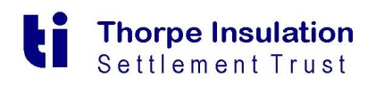



ACH Instructions – Claim Payments
Firm Name:
Firm Address:

Tax ID Number:
Bank Name:
Bank Address (if applicable):

Account Title if Different from Firm Name:
Account #:
ACH ABA Routing #:
Account Type 1: Checking ____ Savings_____
Account Type: 2 Business ____ Personal_____
Bank Contact Name (if applicable):
Firm Contact Name:
Firm Contact Phone:
The Reno Asbestos Settlement Trusts will disburse all claim payments by ACH, effective in January, 2021. Kindly complete the above information and return to the Trusts’ CFO, Barbara Malm, kdornberger@524gtrust.com in Word format. If you secure the document with a password, please send the password under separate cover or contact Barb and she will arrange for an encrypted email chain.

By returning this form, which provides the information above, the firm hereby authorizes the Trust(s) to initiate our firm’s account at the financial institution named above. Further, we agree not to hold the Trust(s) responsible for any delay or loss of funds due to incorrect or incomplete information supplied by our firm or our financial institution or due to an error on the part of the financial institution depositing funds into your firm’s account.

